**Objective** : control relay with Arduino by PIR sensor.

**Components:** Arduino, PIR sensor, wire, USB mini cable, relay

**Circuit :**

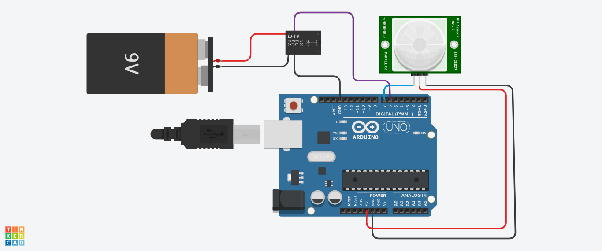

**Working:** In this program, here PIR sensor had used. This sensor works

on pyro infrared principle. When any movement happen PIR sensor

generate it`s signal and that fed to Arduino and related to logic Arduino

gives switch that relay. If you want to operate any device, you have to

connect that device in between Battery`s positive terminal & relay`s

red wire.

Project made By,

Yantra Tech.